Discovering Prehistoric Woolpit: Excavations South of the Old Stowmarket Road, Summer 2020
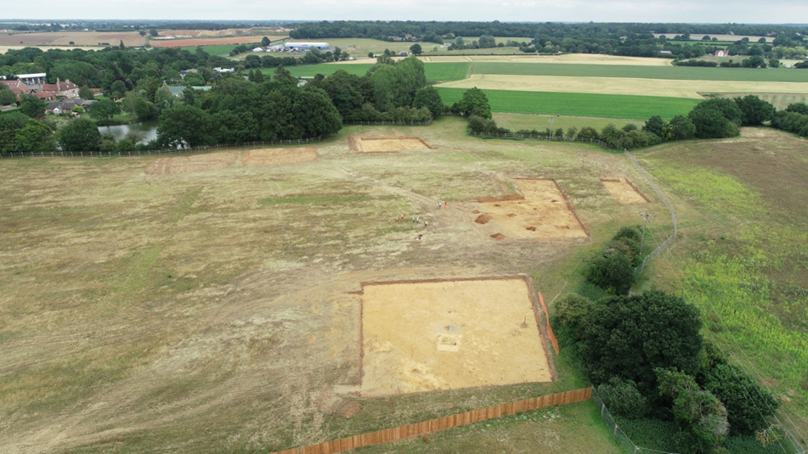
The excavations at Old Stowmarket Road, view east (road to left of photo)

In June and July 2020, Pre-Construct Archaeology carried out an archaeological excavation on land south of the Old Stowmarket Road, ahead of construction of new houses by David Wilson Homes. The site had previously seen two stages of archaeological evaluation, with ‘trial trenches’ being dug systematically across the site to identify any areas of surviving buried archaeology.
After forming part of Woolpit Heath during the medieval period, and then farmland for perhaps several hundred years, the site had become part of the adjacent brickworks by the middle of the 19th century. The trial trenches found extensive evidence for brickearth quarrying across the northern and central parts of the site. This took the form of numerous rectangular, steep-sided and flat-based pits, which might each represent the output or piecework of an individual hired labourer.
On the rising ground in the south of the site, the geology changes from brickearth to sand and gravel, and it was on these lighter soils that the arguably more significant, prehistoric, archaeological remains were found. The excavation focused on this part of the site.
The earliest finds here were small numbers of struck flint tools, flint-working waste, and ‘Mildenhall Ware’ pottery sherds, which are characteristic of activity during the Early Neolithic period, very broadly 4000–3000 BC. The flint tools include a number of small blades which are typical of Mesolithic (‘Middle Stone Age’, c. 8000–4000 BC) and Early Neolithic flint knapping, as well as an unfinished flint arrowhead that might have been abandoned because of flaws in the piece of flint.
The majority of these objects were found in small numbers in a series of probably natural hollows, some of them geological in origin and other likely to be the hollows left by fallen trees. However, one pit contained a larger assemblage of objects, including a quite large group of pottery sherds, animal bone, struck flints, charred wheat grains and hazelnut shells. Radiocarbon dating of the material from this pit is planned in advance of final publication.
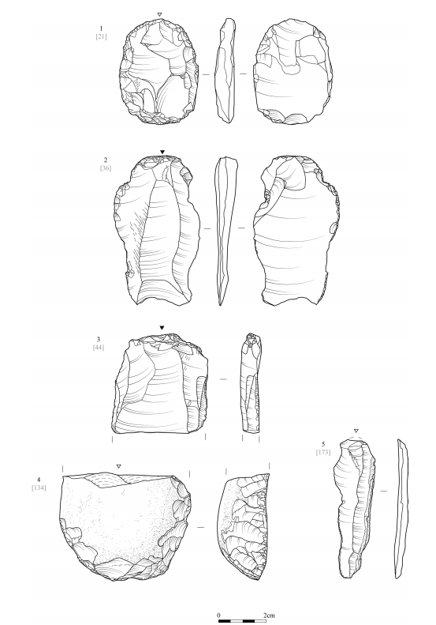
Some of the Mesolithic to Early Neolithic struck flint tools

Despite the arrival of domesticated crops and animals in Britain around 4000 BC, Early Neolithic communities seem to have still lived a largely mobile (nomadic) existence, moving around the landscape in small, extended family groups, and periodically stopping to hunt and gather natural resources. They seem to have been particularly fond of hazelnuts given how frequently the shells are found on Neolithic sites!
Some places, usually located on sandy soils and close to streams and rivers, seem to have been particularly favoured as temporary or seasonal camp sites. These can sometimes be recognised by clusters of pits containing the debris of everyday Neolithic life: broken pottery, animal bones from food preparation, burnt seeds and cereal grains, and struck flint tools. At some sites there is evidence that certain objects were carefully chosen for burial in the pits, perhaps to commemorate particular events in the life of the community or to stake a claim to locations in the landscape. One such Early Neolithic ‘camp site’, contemporary with the finds from Woolpit, has recently been discovered just 5km away, at Fishponds Way, Haughley.
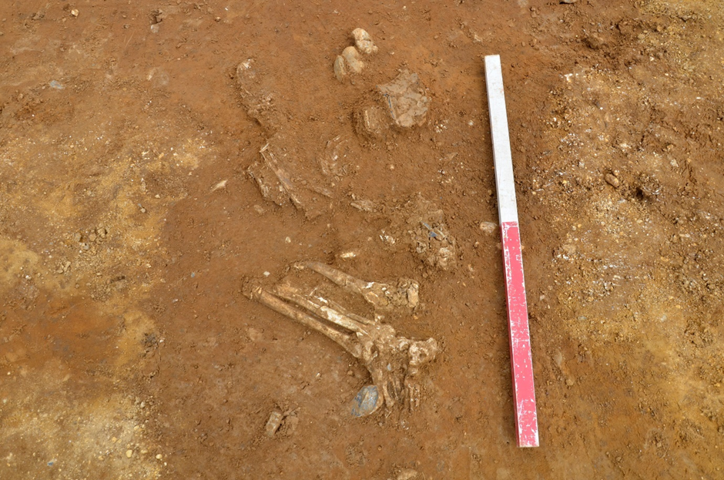
Burial of an elderly man, who died c. 2455–2204 BC, with crushed pottery Beaker behind his head (view north)

The higher ground in the south of the site continued to be important around a thousand years later, in the Late Neolithic to Early Bronze Age. Perhaps the most striking discovery made during the excavation was the burial of an adult man, perhaps 45 years or more old when he died – and therefore venerable by the standards of his day (average life expectancy was probably 30–35). The man had been buried in a tightly ‘crouched’ position, with his head to the north and feet to the south. He was accompanied by a profusely decorated pottery ‘Beaker’ or drinking cup (a form of vessel and style of decoration characteristic of this period). Radiocarbon analysis dates the burial to between approximately 2455 and 2204 cal. BC, the period now referred to as the ‘Chalcolithic’ (‘Copper Age’, before bronze-smelting had developed) or the very early part of the Bronze Age. There were some slight indications that there was originally a mound or cairn over the grave, but this is not certain. This early Woolpit resident appears to have suffered from facet joint osteoarthritis, a condition which would have caused him lower back pain. Dental plaque and extensive tooth wear indicate an abrasive diet and rather poor oral hygiene.
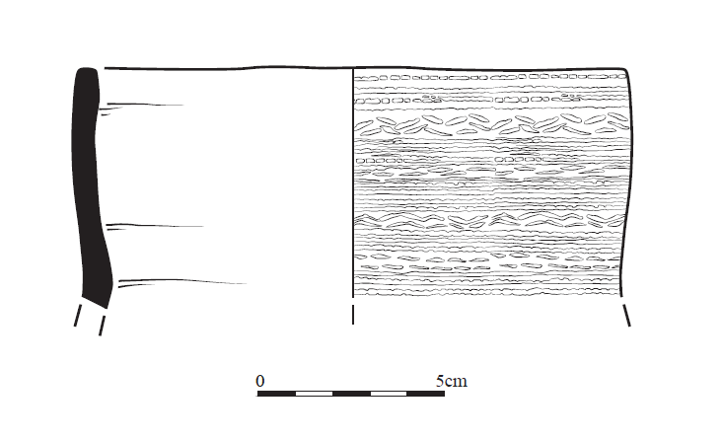
Decorated pottery Beaker

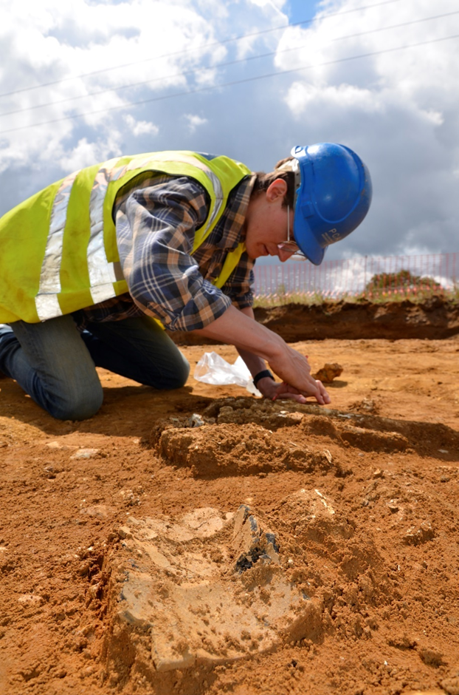
The Beaker burial being excavated, view south

While an intriguing find, the ‘Beaker burial’ is in many respects typical of its period. Other, similar, Late Neolithic–Early Bronze Age graves have been excavated at a range of sites in Suffolk.
However, what is unusual at Woolpit is that the grave is surrounded by a square-ish ditched enclosure, measuring 22.5 x 18.5m (externally). People may be familiar with the broadly circular burial mounds or ‘barrows’ that are quite commonly associated with Late Neolithic and Bronze Age burials, and which often survive as above-ground earthworks in areas of pasture or heathland that have not been ploughed.

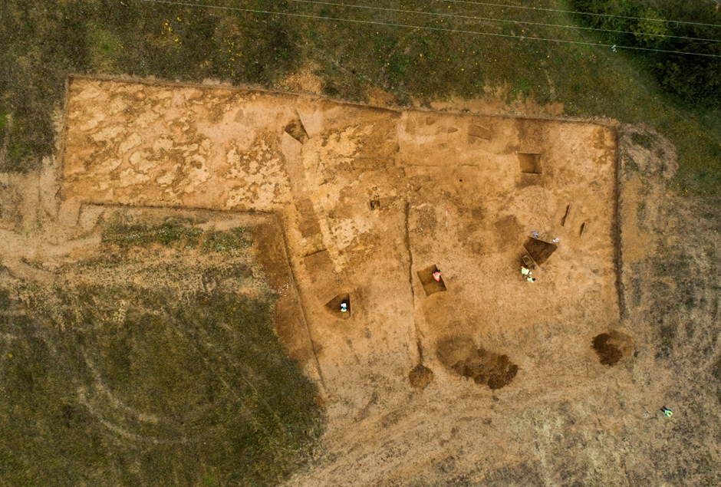
The Bronze Age–Iron Age enclosure (south to top)

However, if it is contemporary with the burial, then this sub-square/rectangular enclosure would be unique for its time, and a significant addition to our understanding of Beaker-period burial customs in Britain. An attempt at extracting DNA from the human remains is planned.
Unfortunately, the finds from the fill of the enclosure ditch are inconclusive as to its date; some small pieces of charcoal from the ditch have been radiocarbon dated to the Early Bronze Age (in the range 2008–1772 cal. BC) and the late medieval period (1449–1626 cal. AD), respectively, but because of where these fragments were found, neither date is thought to be reliable.
Perhaps the best guess is that the enclosure was a later Bronze Age or Iron Age addition to the hilltop, perhaps deliberately surrounding an earlier cairn or barrow over the Beaker grave. Although conjectural, this might perhaps have been a way in which later people living in the area paid their respects to the ‘ancestors’ buried there. Similar-sized burial or mortuary enclosures have been excavated at a few other sites in Suffolk, and in neighbouring counties, are often seem to date to the Iron Age.
Providing some weight for an Iron Age date, a few ‘rubbish’ pits excavated towards the western edge of the site indicate a Middle Iron Age (c. 350 – 50 BC) settlement somewhere close by.
There was no evidence of activity at the site after the Iron Age and it may be that the site had already become heathland grazing by the Roman period. This land-use continued into Anglo-Saxon times and through the medieval period. A silver long-cross penny of Edward III (1327–1377), found in the topsoil by metal-detector, may have been a chance loss, though probably not by one of the poor shepherds who are likely to have been the most frequent visitors to the heath at this time.

Tom Woolhouse and Jon House
Pre-Construct Archaeology (specialist contractors, fulfilling the planning condition that an archaeological excavation had to be carried out before construction).
Further reading
The final report will be available via the Suffolk Heritage Explorer (https://heritage.suffolk.gov.uk/home) or the Archaeology Data Service (ADS).

The ADS holds copies all of the recent reports on archaeological work in Woolpit. The full list can be found here: https://archaeologydataservice.ac.uk/archives/view/greylit/query.cfm?REDSQUIDARCHIVES_9f9c30e1-84e4-49a9-a584-4dcf95d78526_0

or go to https://archaeologydataservice.ac.uk/archives/view/greylit/query.cfm and add ‘Woolpit’ into the ‘Where’ search box, ticking the ‘parish’ box.

